Hey folks.
I would like to give an update. On Wedensday as Ameen mentioned in the chat, we get to work and Train 3 different AI models. 1 is with the Datasets that Everyone were downloading and labling and resiszing. Another one is with only Spreewald images and videos ( which for background images we could also consider those background only no fish images ) and the last would be a model that All the images and videos from both Spreewald and other datasets we gathered. We do this and compare them so we could see which one can do better in detecting and giving us infos.

Also on my side these were the tasks that I have done so far from Wedensday.

- Found a way to extract all frames as images from videos. Tested for now on only one video. The video itself has got 17415 frames in total. It extracted 1172 images from those that contain fishes. The algorithm does use an AI already trained yolo ( not from us from world ) which are trained on Microsoft World COCO dataset. It has some features which are some fishes as well. I cannot quite tell which species this AI model is being trained on, but my purpose is for now extract fishes regardless of their species. I have resized all the 1172 frames to 720px resolutions to prevent OOM error using a simple Py code. Then I started dehazing those extracted frames. Good results were expected and good results also came by. The fact is that We could use these frames also for training.

- The videos had some problems. Both original video and dehazed when applied to it. These problems were mostly with format of the frames and videos. Since the code did not work for it I had to change the type of it so I have written a code where we could change the type to a better readable h264 format. Then I tested the dehazing and upgrading resolutions on them. The results were promising.

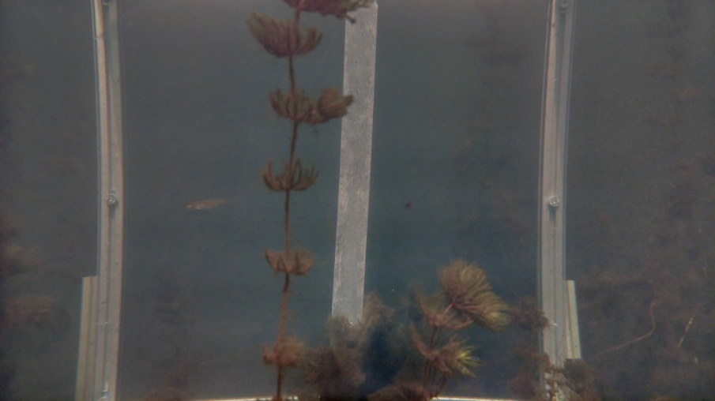
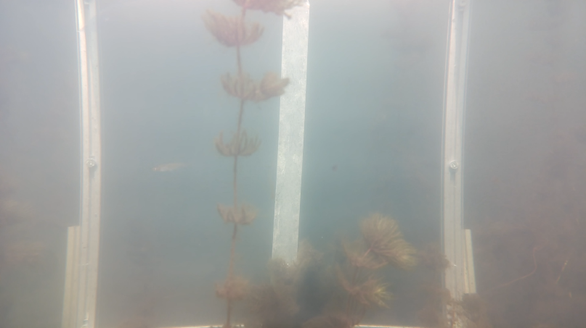

- Also talked to Johannes Kohl about the insta360 type videos he suggested using Open CV. However the results were not quite well and it took a lot of time even on one simple 160mg video to process it. We cannot do this for each of these videos. Therefore I decided to go a better way which is using the insta360 media SDK. The results of that are outstanding. Also ran the dehazing algorithm to some frames of them not images and the results unfortunately were not good, when MSRCR method is being applied to them. I have upgraded the resolution, however, with other AI trained models which are down below.

- I have received instruction on to use the DGX GPUs Prof. Zug was discussing about, which I have already sent them

In a suammary, I have fixed the dehazing + upgrade resolution and color restoration. I used with MSRCR + RIFE 4.25 for video upgrades and MSRCR with Nomos8k-SPAN (4x) for images in order to dehaze and upgrade the resolutions.

I would like to inform you that, for now the dehazing part is done. The algorithms are not clear that which methods they are. I try to upload all results until Sunday.

Also, I will get started with vision transformers soon.

